DSE6620

Project 1

Ethan Michaels

**Introduction and Data**

In this project I am looking to recommend which sports team you should buy with a budget of $4 Billion. I will be looking at data from the 5 major sports leagues from 2020, 2021, and 2023 (we are excluding 2022 due to the Corona Virus outbreak). I’ll be evaluating their revenue, income, debt of the sports team as well as the Population of the Closest Metro Area. Throughout the report Revenue and Value are the most important variables. In Figure 1 below we can see the Revenue to Value Ratio of every Sports League from 2020 to 2023. The NHL consistently has the highest Revenue to Value ratio from year-to-year with the MLB right behind in two of the three years. On the other hand, In Figure 2 which shows the actual Revenue to Value numbers, NFL has the highest Revenue amongst all leagues, and although NHL has the highest Revenue to Value Ratio, they are one of the lowest in terms of Revenues by Team.

**Figure 1: The Average Value to Revenue Ratio of every League from 2020 to 2023**

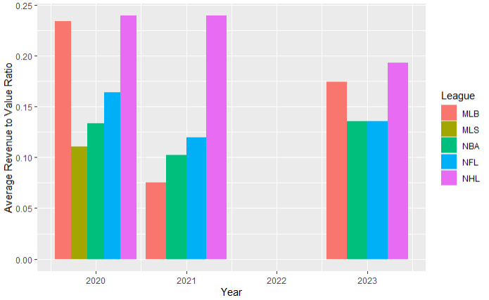

**Figure 2: Value and Revenue of Every Sports Team from Each Year**

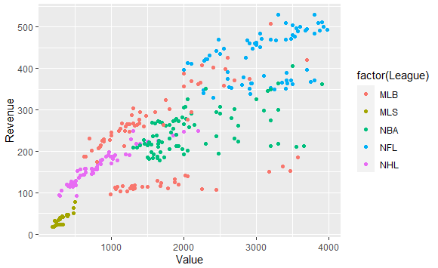

In this report I will be recommending what team(s) you may want to purchase that are within your budget, for the remaining of the report I will be looking into the Revenue, Value, and Debt of every team as those are a few of the important factors within a team. Before I delve deeper into each league I modified the data by removing all MLS teams due to lack of information with only having one years’ worth of data, the second modification was to remove all team data that was from 2020 and 2021 as its outdated and due to the coronavirus a lot has changed in terms of the outlook of sports in general.

**Recommendation**

The biggest factors that come out of purchasing a team is their Debt and their Revenue, below in Figure 3 to Figure 6 shows the Debt to Value Ratio and Revenue to Value Ratio for each League. When recommending you a team I want to set you up well, I won’t be considering any teams that are extremely high on the Debt to Value Ratio unless they have a high Revenue to Debt Ratio. From all four leagues there is only one team that stands out from the rest within the range that we want which is a high Revenue to Value Ratio and Low Debt to Value Ratio, that is the Cincinnati Bengals which would cost you $3.0 Billion. That being said I think purchasing the Bengals would be the best decision and with an incredible fan base and a growing franchise now would be the best time to buy the team. Going forward if you are looking to spend all your budget, which leaves you with $1.0 Billion we would be left looking at most of the teams in the NHL. Figure 7 shows the remaining sports teams with a valuation of $1 Billion or less, from looking at the graphic it doesn’t seem like purchasing another team would be the best Idea unless you went towards the Las Vegas Knights, San Jose Sharks, or Calgary Flames.

**Conclusion**

After looking deeper into professional sports valuations and a budget of $4 Billion I would recommend purchasing the Cincinnati Bengals (NFL) which would only cost you $3 Billion. If the buyer is looking into multiple teams then I would recommend also purchasing either the San Jose Sharks (740 Million), Las Vegas Knights (965 Million), or Calgary Flames (855 Million).

**Figure 3: NFL Debt to Value Ratio compared to Revenue to Value Ratio**

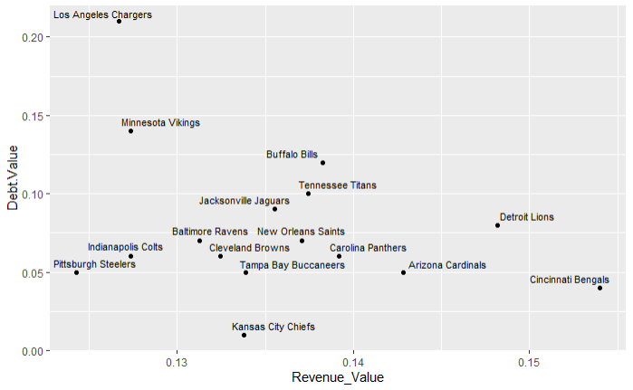

**Figure 4: MLB Debt to Value Ratio compared to Revenue to Value Ratio**

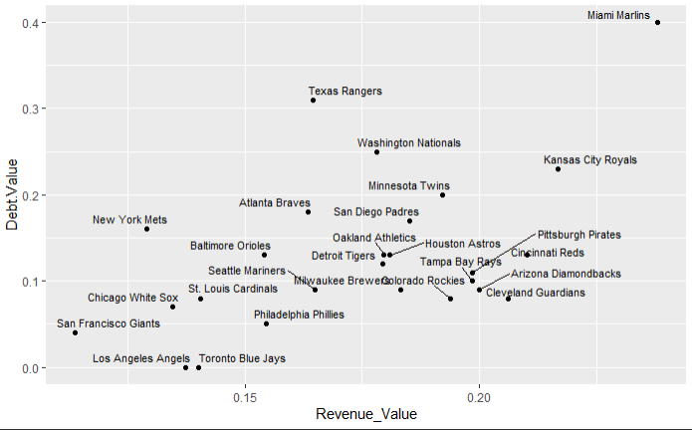

**Figure 5: NBA Debt to Value Ratio compared to Revenue to Value Ratio**

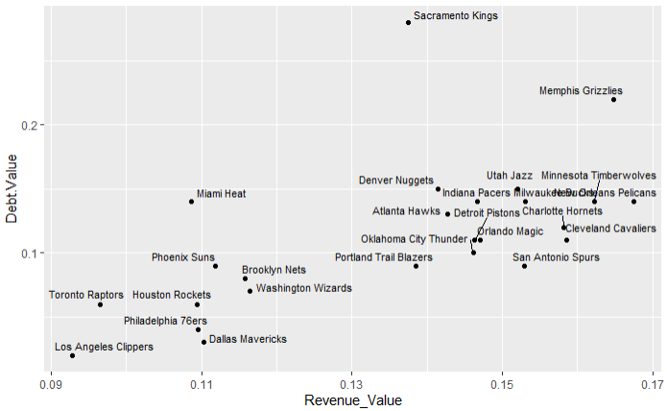

**Figure 6: NHL Debt to Value Ratio compared to Revenue to Value Ratio**

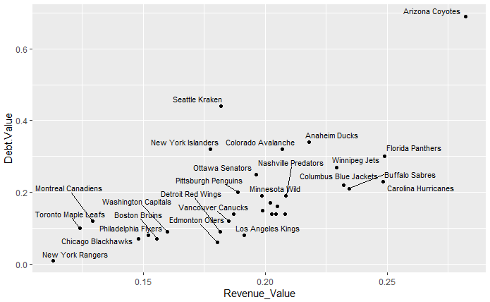

**Figure 7: Teams with Value below $1 Billion**

